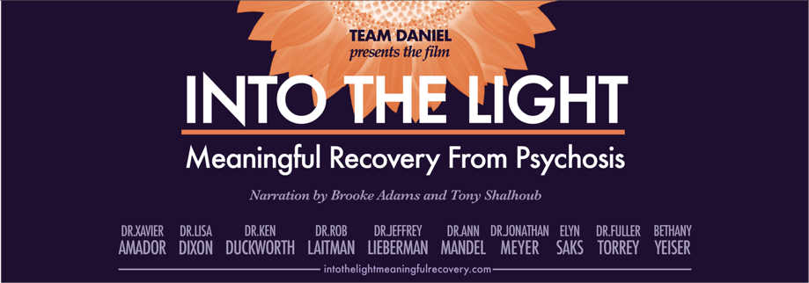

AN URGENT PLEA…Quotes from viewers

Xavier F. Amador, PhD, President, The LEAP Institute
Moving, enlightening, educational, such an important and loving film.

Regina Graham, MD, Medical Director Early Psychosis Programs, UC Davis
I hope that this amazing documentary will be spread far and wide in 2025 and beyond.

João Gama-Marques Homeless Outreach Psychiatric Engagement for Lisboa (HOPE 4 Lisboa)
Consulta de Esquizofrenia Resistente - Hospital Júlio de Matos Lisboa, Portugal, European Union
Allow me to say thanks and congratulations you for the amazing movie: "Into the light meaningful recovery".
It validates our work here in Lisboa. It gives us the motivation to keep on with our struggle helping treatment-resistant schizophrenia patients, living and dying in the street and asylum of Lisboa.
It is very hard to get positive feedback around here. But watching this movie, with the participation of such a group of experts, inspires us a lot to keep with our ordeal. To see stories so similar to the ones we see everyday, plus the cover of the books we have been inspired by, etc.

Eric Smith, LPC, Therapist & Advocate
This film is a huge source of inspiration! I am glad everyone involved made the decision to be part of this powerful message of meaningful recovery.

Stephanie Anakwe, MD, Resident NYU Langone
This is simply eye opening.

Alexandra Gordon, MD Resident NYU Langone
Wonderful! A personnel look into the challenge of schizophrenia and an informative vantage poinof how helpful clozapine and community support can be.

Nancy Li, MD Resident NYU Langone
This film provided valuable insight into how families are impacted by a psychiatric diagnosis. I think we often focus on the patient without fully understanding the full scope, despite calling collateral & family meetings
On Sep 12, 2025, at 6:34 AM, João Gama-Marques <joaogamamarques@gmail.com> wrote:

Margaret, MD, Mother
"Into the Light" should be a mandatory curriculum component for training psychiatry residents in the US. Psychiatrists young and old must eschew long-held misinformation discouraging use of clozapine for treatment of schizophrenia spectrum disorders, and heed the compelling accounts that attest to its power in driving meaningful recovery, as illustrated in this movie.
Too many individuals have experienced unimaginable and unnecessary suffering from schizophrenia, with parents being told to accept that the child they once knew is gone. Doctors often counsel parents that the most commonly prescribed anti-psychotics that merely keep their children out of jail/hospitals are "good enough." All too often, they are loath to offer clozapine as an alternative, erroneously touting it as a "dangerous" medication. "Into the Light" provides powerful testimony from doctors, parents and, most importantly, people with schizophrenia, whose lives have been restored by clozapine after wasting years (sometimes decades) on other ineffectual anti-psychotics.
So, an urgent plea to psychiatric care providers: WATCH THIS MOVIE. It is impossible to listen to the accounts of how clozapine has transformed lives and continue to deprive patients of their best chance at meaningful recovery.

Robyn Brentano, VP development, MIT Dalai Lama Center
You wove together a very complex but very human story that I hope will be aired many times on mainstream media. There's so much more to say but I just wanted to thank you for sharing the film. The people you profiled--those under treatment, family members, advocates, and medical and psychiatric practitioners--all serve to repudiate the greed-driven pharmaceutical industry, but you handle that aspect without being polemical.

Sue Maida Co- Founder The Angry Moms
Viewing should be mandatory for all "professionals" working with SMI. Also, all those that come into contact with those suffering from SMI, like law enforcement, lawyers, 911 operators, judges, etc

Sandy, NP
Just watched the film…wow…it’s beyond powerful and leaves me feeling very hopeful for those with SMI. My sister has rapid cycling bipolar 2, so I can relate to many of the challenges that accompany SMI and the need for new treatments and more hope….

Jody Shapiro, former MLB, NBA & NHL executive
What I thought was so effective is how you interwove all the constituents, from the parents to the children, from the health advocates to the organizations. And ending with hope and paths toward effective treatment made the film worth watching from beginning to end. You and the entire production deserve a great deal of credit. You call this "a labor of love" and it truly comes across as a work of sincere concern and devotion--to all our loved ones, however challenged any one of them may be. Great work on a very important subject. Thank you!

Bear, Mother
1st time I ever watched something like this with my 23-year-old. We got 45 minutes in and he went back to the living room. I think he was more into listening to the other people like him with schizophrenia. This is 1st time in 3 or 4 years ever seeing other people with his same experiences and diagnosis.

Melanie, Mother
My daughter agreed to watch it with me at the weekend, she still has limited insight and understanding of schizophrenia. I wanted to show her what a great, kind, caring community you have created, there is hope, to never give up and to let her know she is not alone. She said after watching Dr Laitman and his wife are lovely people and she is now following Bethany Yeiser and Dan on Instagram, positive steps. Thank you to everyone who created the documentary, you are all amazing, inspiring people.

Mother
I watched Into the Light when it was newly released and shared it with the psychiatrist from the Kings County PHP program. As a mother of a son with schizophrenia, I found this documentary to be both informative and inspiring. Hope is paramount—we need hope, knowing that meaningful recovery is possible. It makes all the ups and downs bearable. I have also shared this documentary with family members and my therapist. Seeing Elyn Saks was great; she was my first glimpse of hope when I learned of my son’s diagnosis. Thank you for making this documentary for everyone.

Jennifer, Mother
Thank you to send the video, it has given me new knowledge language to help Erica understand her condition is a neurological disease that needs medical treatment. That she is not the only person to experience schizophrenia and can recover from it. The personal story journeys of the individuals in the documentary are extraordinary recoveries! It gives me hope Erica will be able to do the work with mental health treatment to reach a successful recovery be well in life.
…
Early this morning, Erica voluntary admission herself into treatment. I am so relieved she finally was able to understand she needed go to mental health care. It was a calm submission versus past behavior of anger/denial. Tremendous relief she did so voluntarily…I did use knowledge/language from your film to convince her. I feel the most significant point was explaining to her she has a neurological disease, it’s not her fault. It is like having a disease such as cancer and needing medical treatment for a cure.

Maryann, Mother
How amazing is this movie?? Please share my praises and gratitude! I have shared this movie with anyone I think might benefit or have an opportunity to share.
Clozapine has saved Bennett’s life. Dr. Laitman and his wife (Dr.) Ann, and the Team Daniel TEAM are absolute f’ing heroes.

G. Brian Karas, Children’s book author and illustrator
Congratulations on your well-done film! It’s beautifully handled, has a lot of valuable information and messages of hope for people struggling with schizophrenia.

Gabrielle
Very informative on an important topic, heartbreaking how the medical profession has failed people with mental health issues.

Maria, Mother
For years, I’ve tried to explain to my family and others that Sam is not okay. While he may appear stable, I know in my heart that he is far from living the life he could have with the right support. Instead of receiving understanding, I’ve been met with dismissal, criticism, and outright gaslighting. My ex-husband tells my children and others that I’m crazy, unstable, and incapable, encouraging them to distance themselves from me. My children—Tommy (24) and Susan (18)—have internalized this narrative, often accusing me of overreacting, exaggerating, or just looking for drama. Even my neighbors and extended family have echoed these sentiments, leaving me completely isolated.
But something changed this past weekend.
Tommy recently moved back to Chicago for work, and while he was coming to pick out furniture for his new apartment, I convinced him to watch Into the Light with me. I told him, “More than anything, I need you to understand what I’ve learned about schizophrenia. If you still think I’m overreacting after watching, I’ll stop pushing, but I need just one hour of your time.” He resisted, but eventually, he sat down—and something remarkable happened.
By the time you were running with the team, Tommy's entire perspective shifted. He went from rolling his eyes to taking notes and asking questions:...
For the first time, Tommy understood. Watching other mothers describe the same struggles I’ve been facing made him realize that I haven’t been exaggerating or losing my mind. He apologized to me—something I never thought I’d hear. He told me, “I’m sorry for the way I’ve treated you these past few years.” He even said he wants to help find better care for Sam and be part of the solution (actually he told me to get on a plane with Sam and fly to you today).
I was so shocked and relieved by this breakthrough that I forwarded Into the Light to a few family members and close friends. The response has been overwhelming. People who once thought I was “crazy” have called to apologize and ask how they can help. They admitted they had no real understanding of schizophrenia and now realize how much I’ve been fighting for Sam all along. For the first time, I feel like I’m gaining allies instead of being dismissed or ignored.

INTO THE LIGHT WEBSITE: to see the film and for information: Intothelightmeaningfulrecovery.com
CONTACT: Karen Bresolin at kpmbresolin@gmail.com

TEAM DANIEL WEBSITE: Teamdanielrunningforrecovery.org
TD FACEBOOK: https://www.facebook.com/groups/www.teamdanielrunningforrecover.org

